## **a)**

Data Model for the given csv files which contain details of IPL (Indian Premier League) from 2008 to 2019 is shown below.

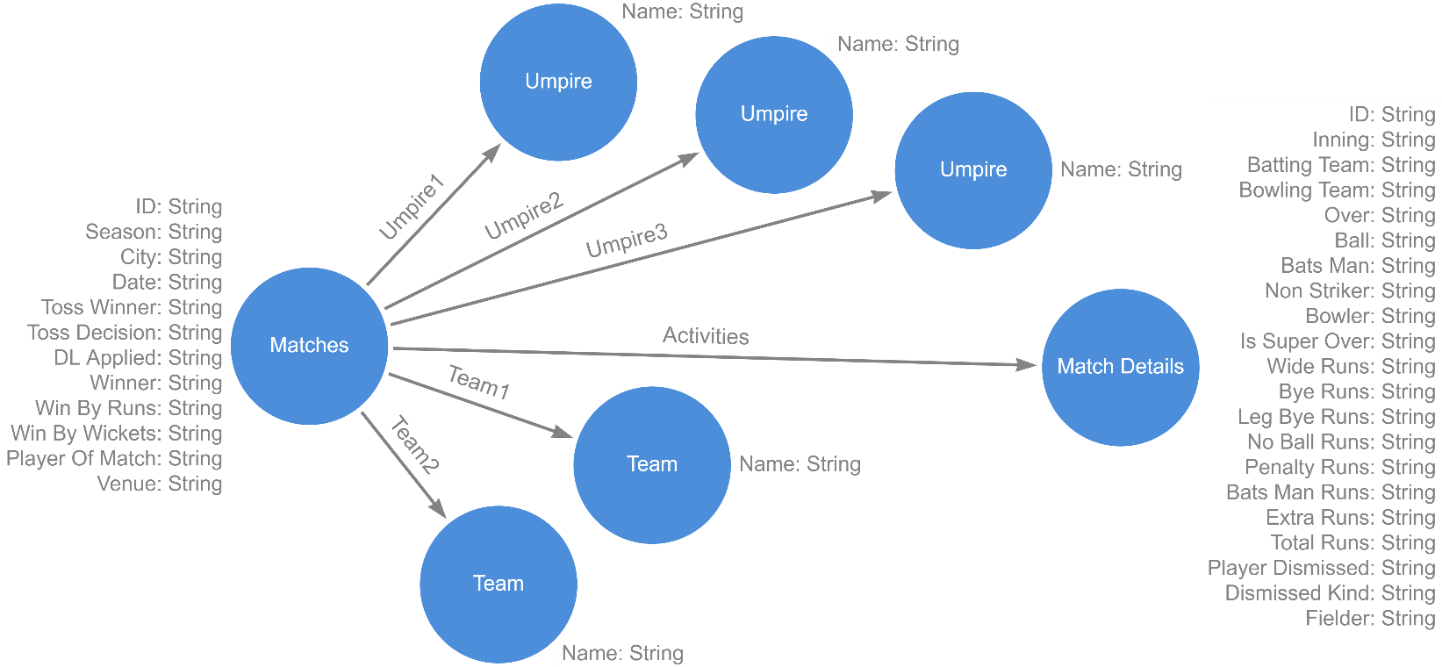

Figure 1: Data Model for IPL (Indian Premier League) from 2008 to 2019.

## **b)**

Nodes and relationships according to the above data model are created which are shown below.

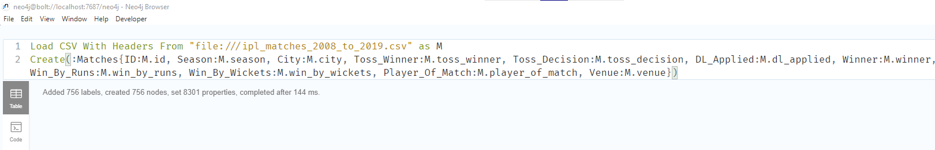

Figure 2: Creating Node "Matches".

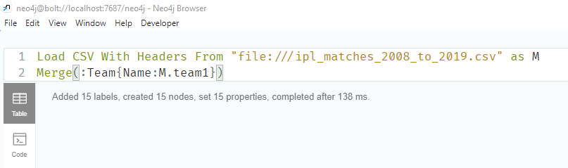

Figure 3: Creating Node "Team".

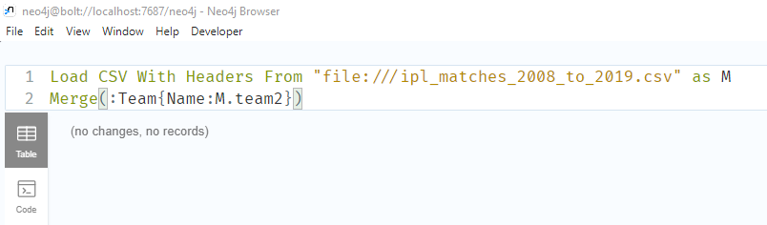

Figure 4:Creating Node "Team".

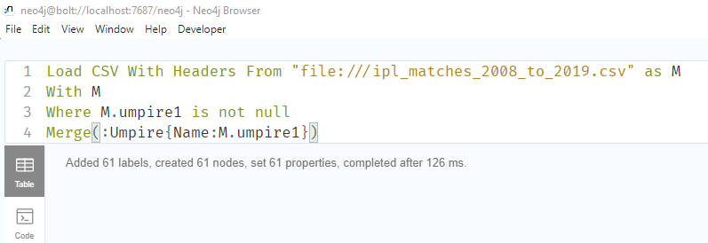

Figure 5: Creating Node "Umpire".

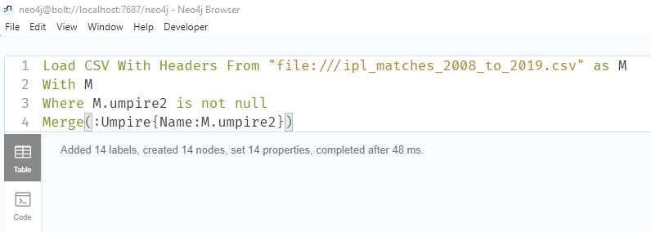

Figure 6: Creating Node "Umpire".

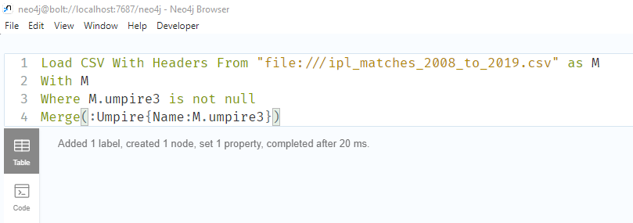

Figure 7: Creating Node "Umpire".

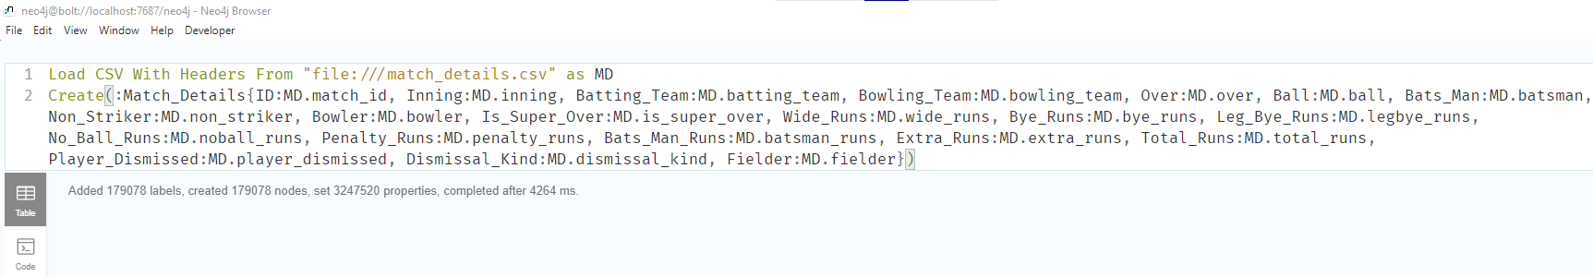

Figure 8: Creating Node "Match_Details".

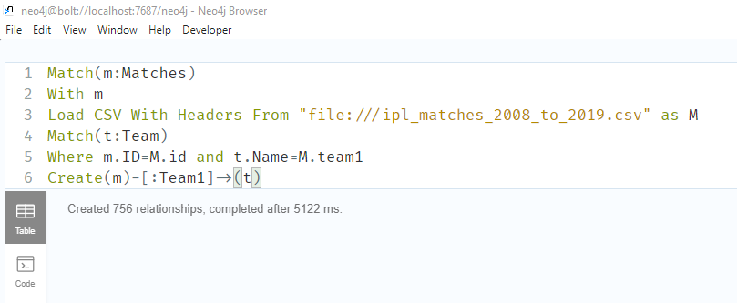

Figure 9: Making relationship "Team1” between "Matches" and "Team" according to the given csv file.

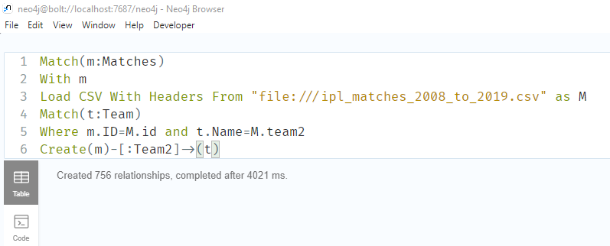

Figure 10: Making relationship "Team2” between "Matches" and "Team" according to the given csv file.

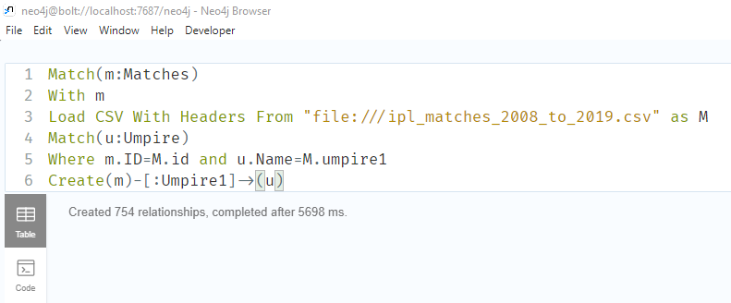

Figure 11: Making relationship "Umpire1” between "Matches" and "Umpire" according to the given csv file.

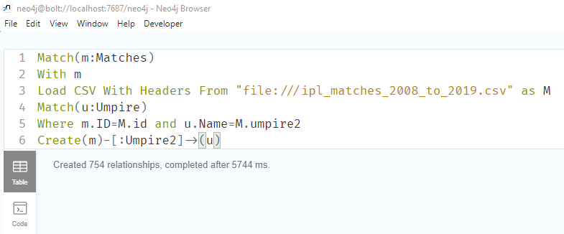

Figure 12: Making relationship "Umpire2” between "Matches" and "Umpire" according to the given csv file.

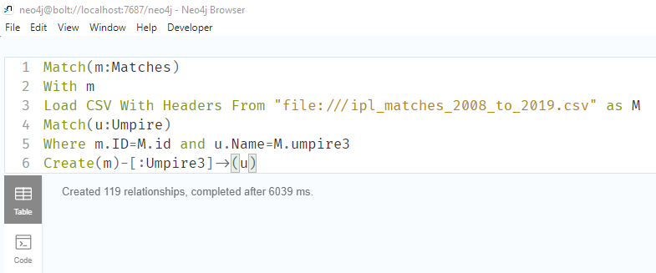

Figure 13: Making relationship "Umpire3” between "Matches" and "Umpire" according to the given csv file.

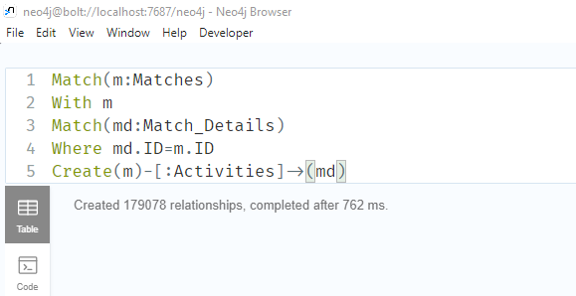

Figure 14: Making relationship "Activities" between "Matches" and "Match_Details".

## **c)**

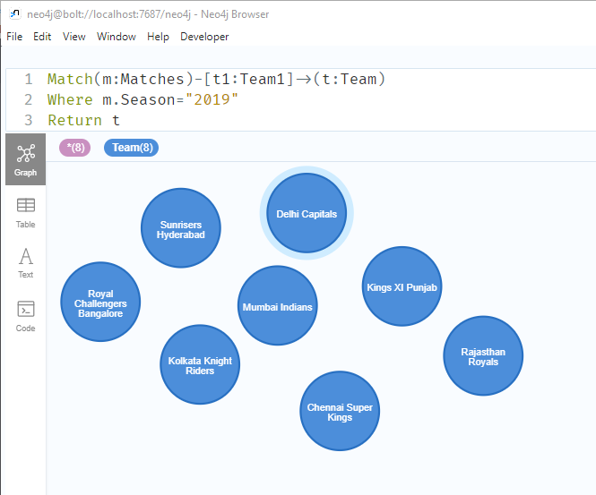

Figure 15: Showing all the teams from season 2019.

## **d)**

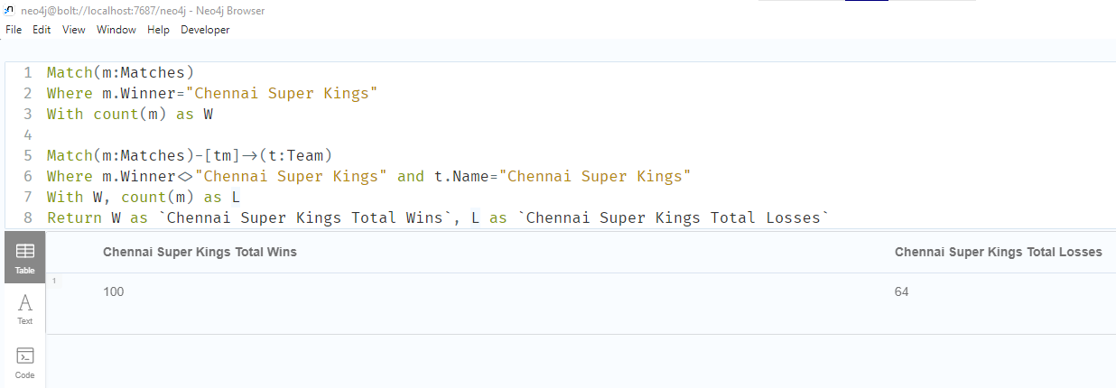

Figure 16: Showing how many matches “Chennai Super kings” won and lost

## **e)**

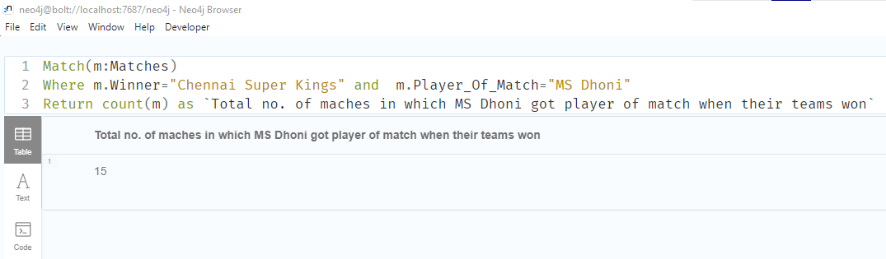

Figure 17: Showing how many times does “MS Dhoni” got the player of the match when their teams won the match.

## **f)**

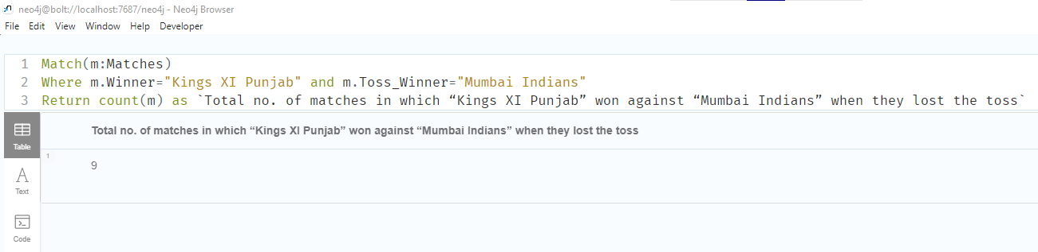

Figure 18: Showing how many matches does “Kings XI Punjab” won against “Mumbai Indians” when they lost the toss.

## **g)**

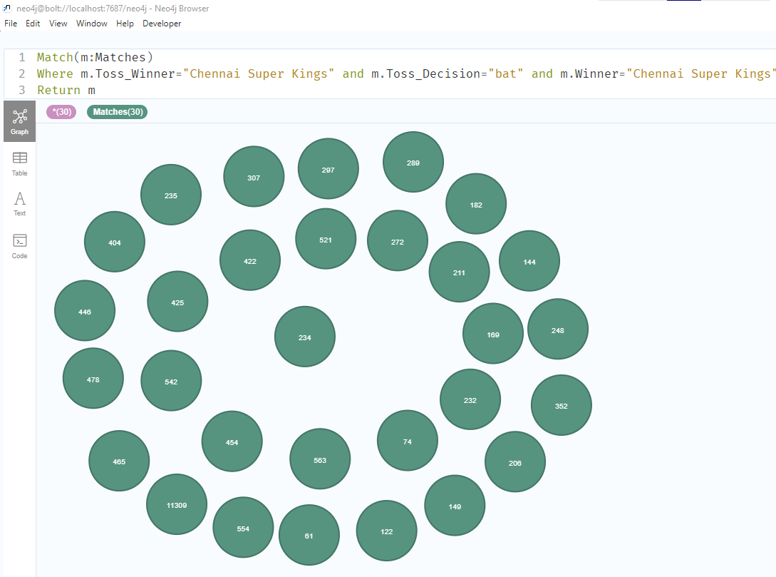

Figure 19: Showing all the matches in which “Chennai Super kings” won the toss, elected to bat and won the match.

## **h)**

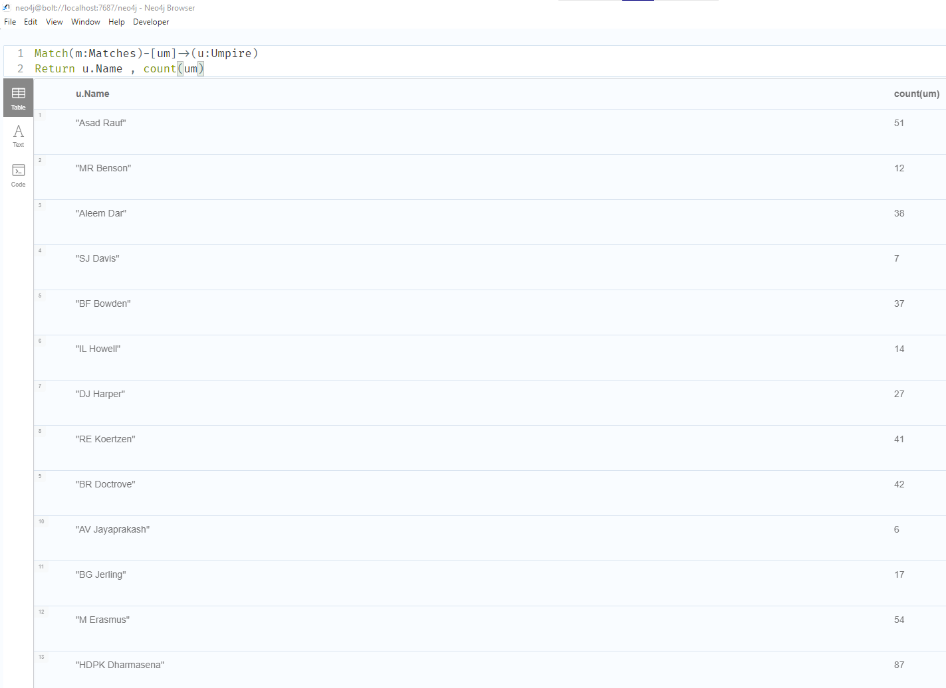

Figure 20: Showing all the umpire and the number of matches they have umpired.

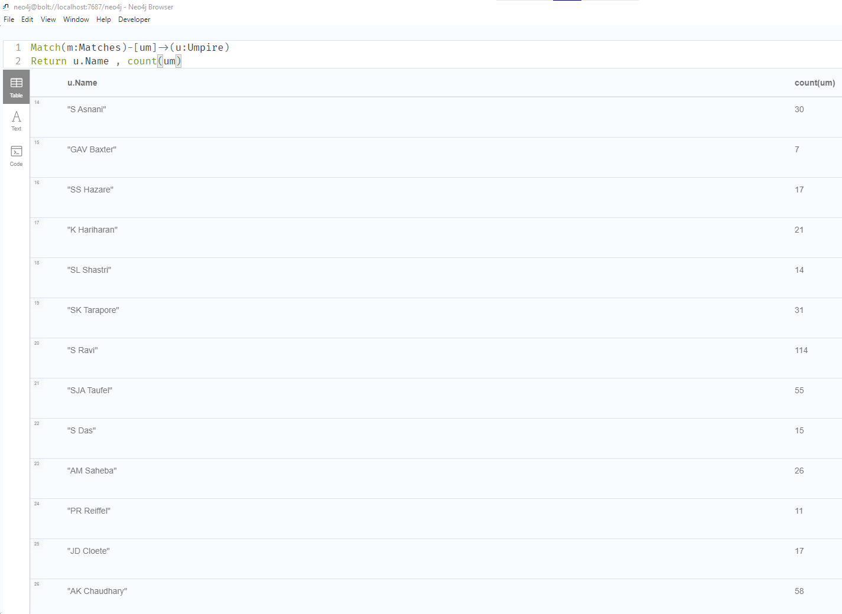

Figure 21: Showing all the umpire and the number of matches they have umpired.

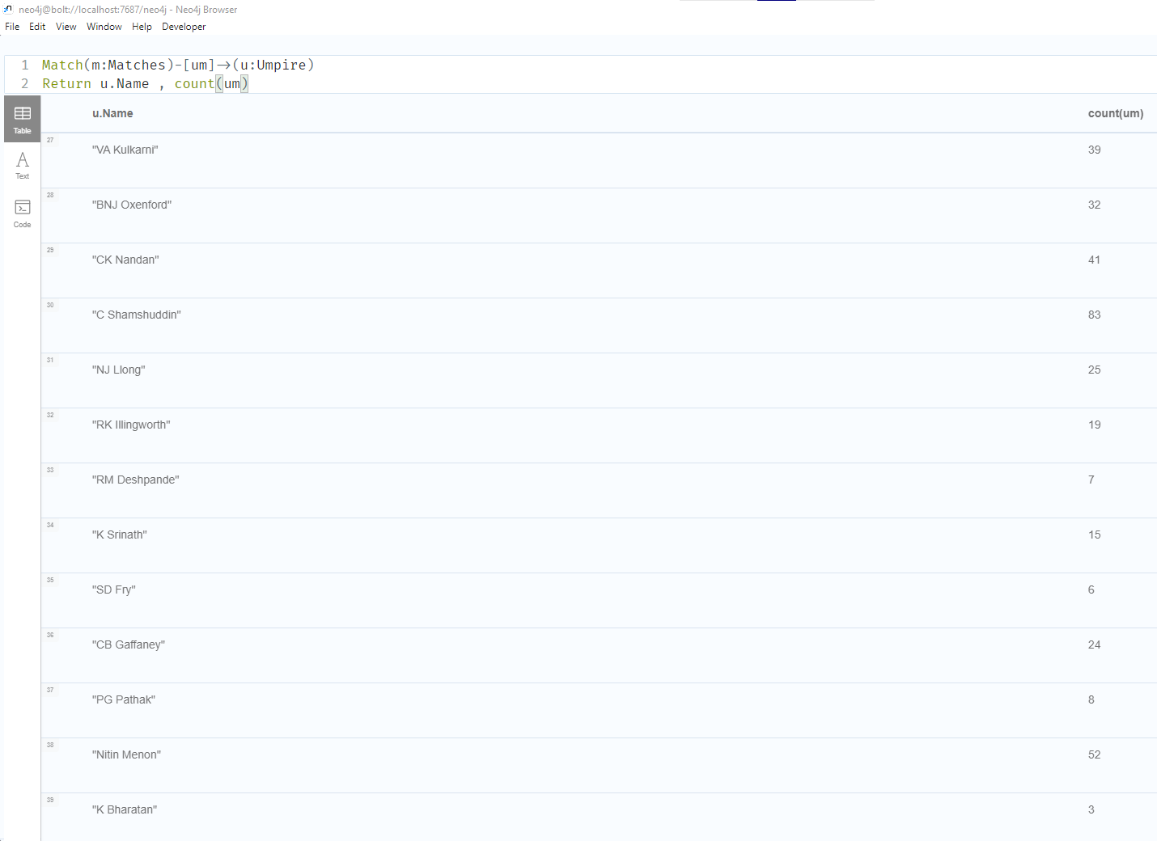

Figure 22: Showing all the umpire and the number of matches they have umpired.

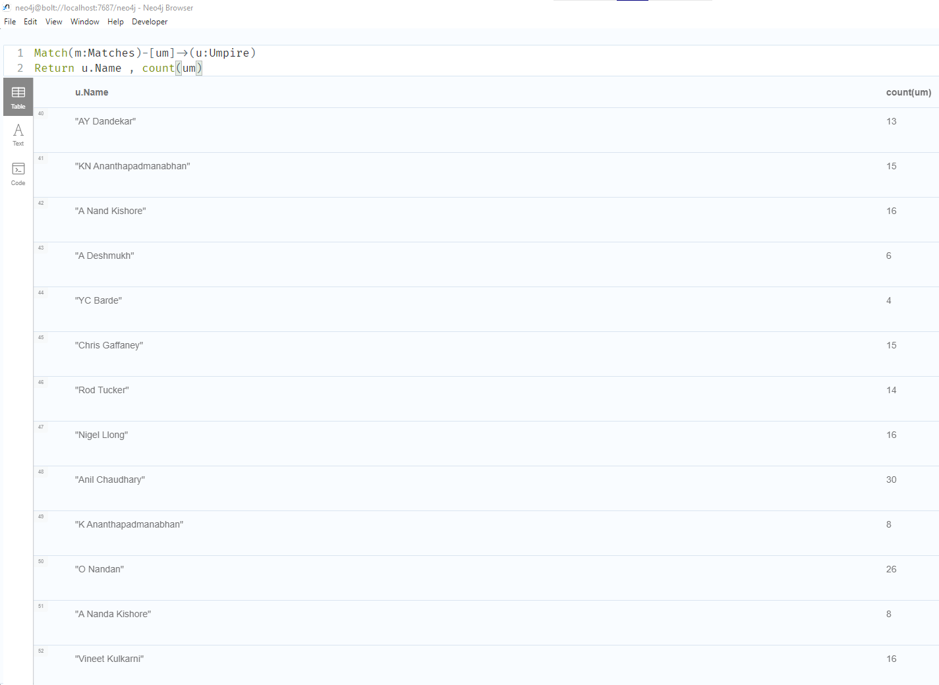

Figure 23: Showing all the umpire and the number of matches they have umpired.

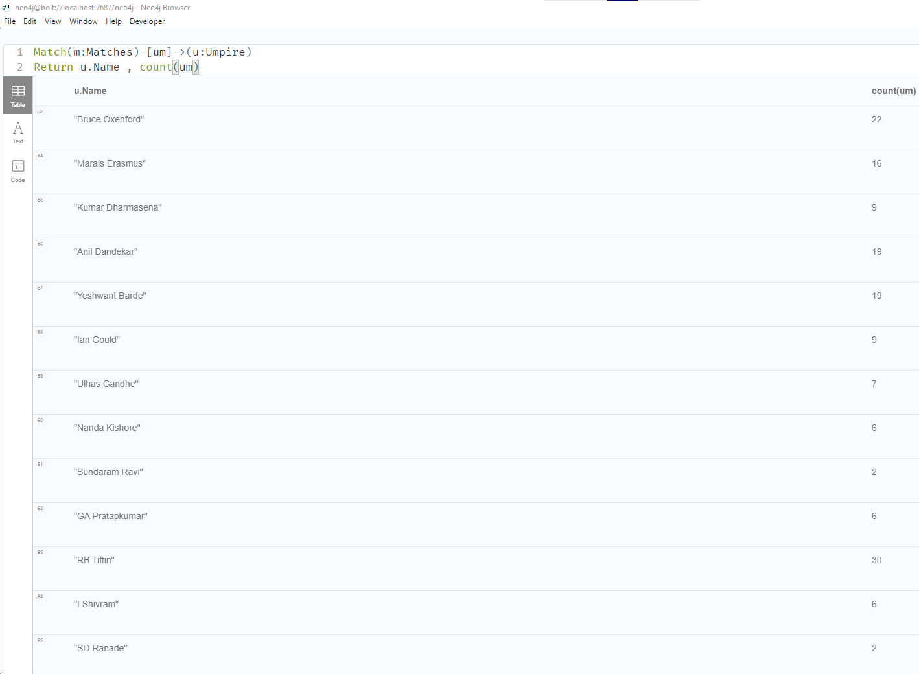

Figure 24: Showing all the umpire and the number of matches they have umpired.

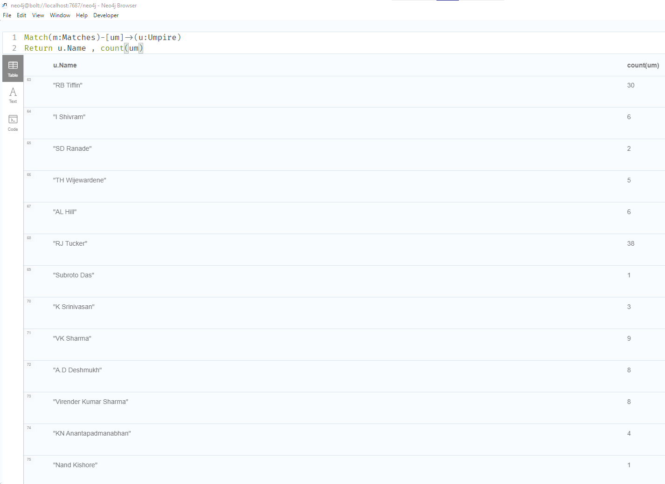

Figure 25: Showing all the umpire and the number of matches they have umpired.

## **i)**

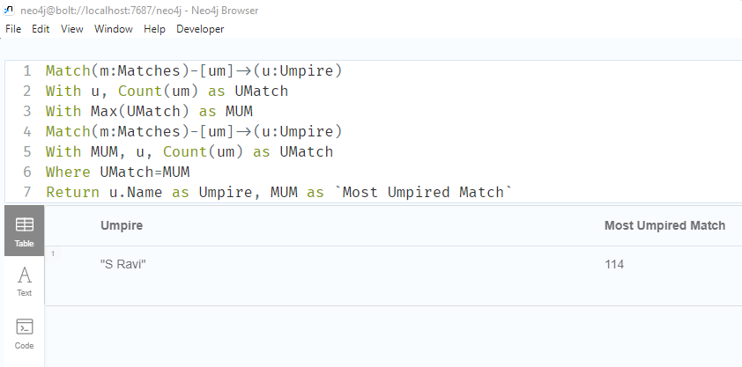

Figure 26: Showing who umpired the most matches.

## **j)**

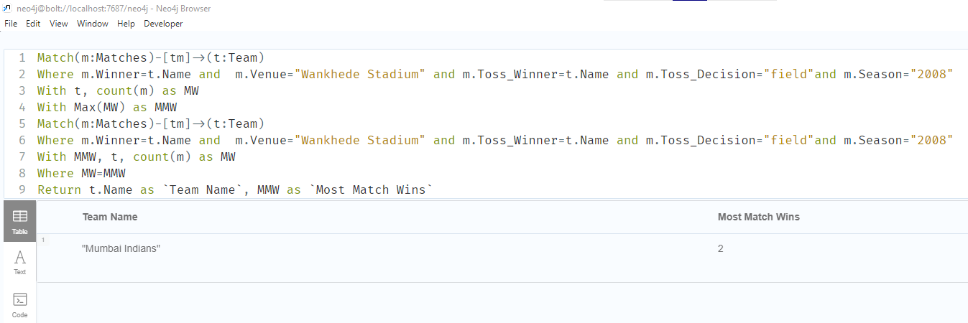

Figure 27: Showing which team won most matches in “Wankhede Stadium” venue when they won the toss and chose to field in year 2008.

## **k)**

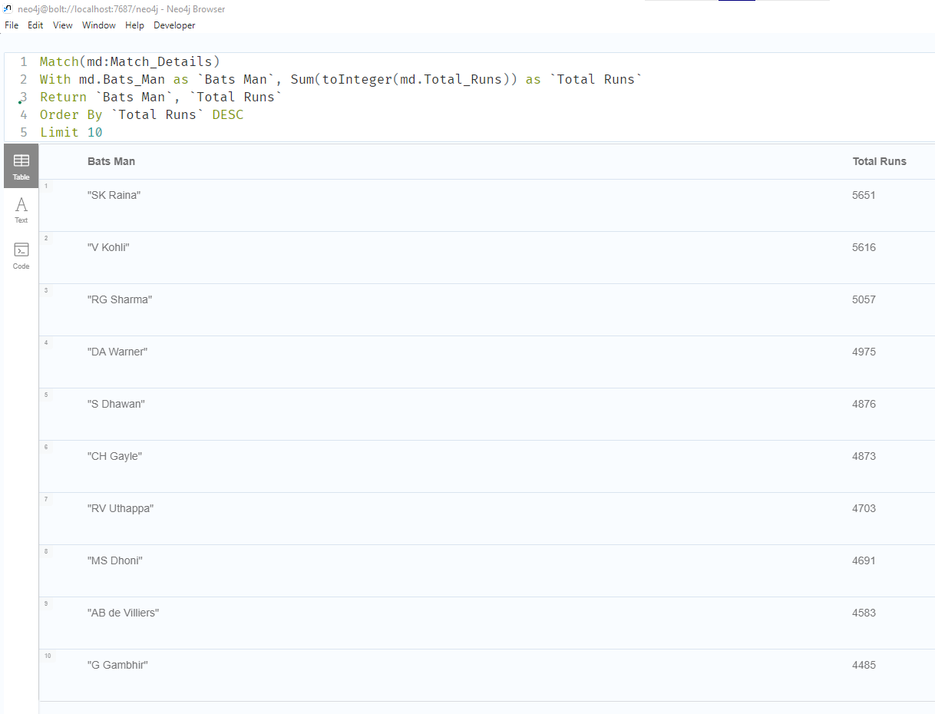

Figure 28: Display top 10 batsman in IPL season 2008-2019.

## **l)**

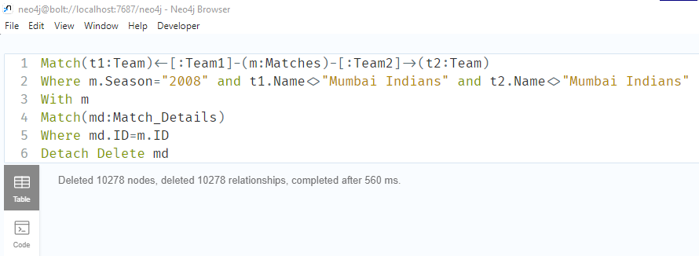

Figure 29: Deleting all the Match Details from season 2008 except the details of the matches played by “Mumbai Indians”.

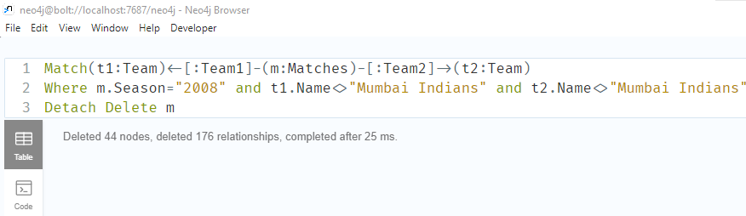

Figure 30: Deleting all the Match from season 2008 except the matches played by “Mumbai Indians”.

## **m)**

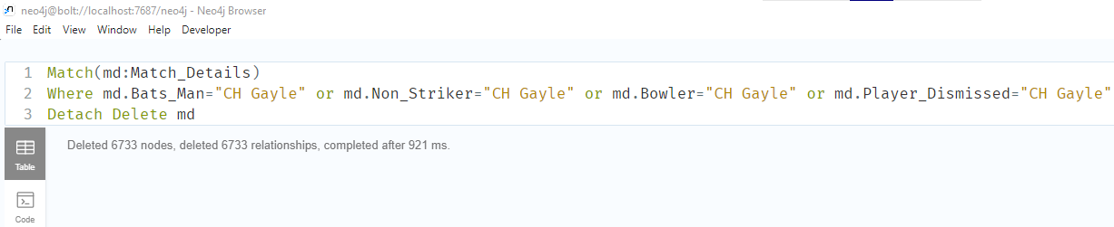

Figure 31: Deleting all the details of CH Gayle from Match Details Node.

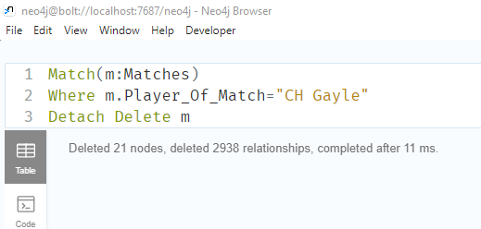

Figure : Deleting all the details of CH Gayle from Match Node.